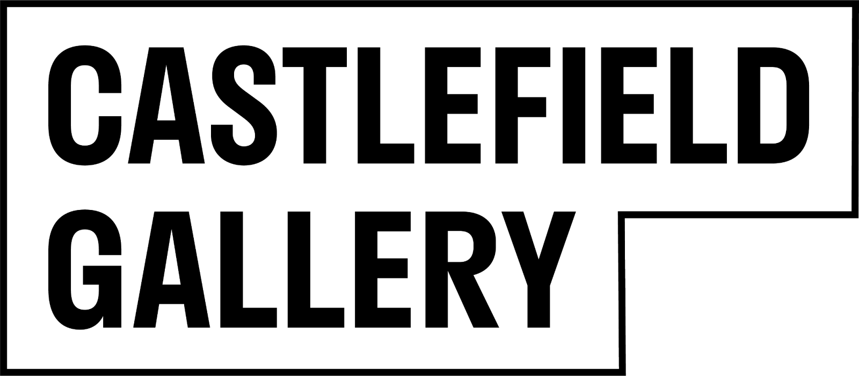

**Press release**

**November 2024**

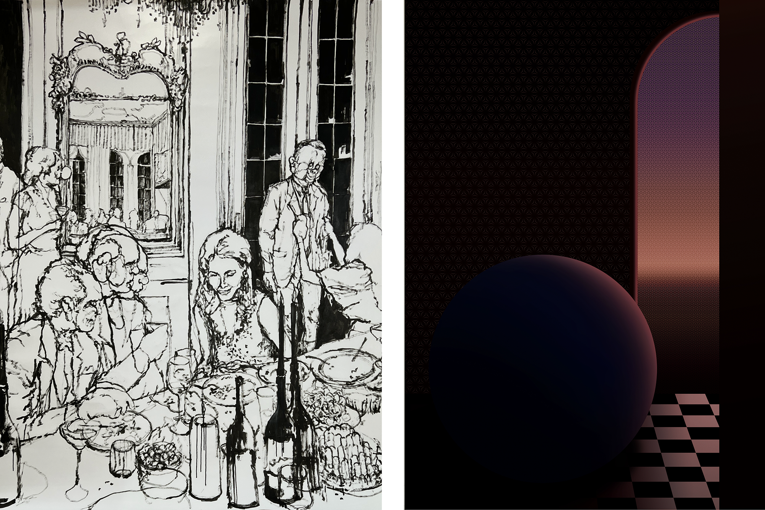

Left: Matthew Wood, *Vol-Au-Vent*, 2024. Image courtesy of the artist. Right: Kay Shah, *Horizon*, 2023. Image courtesy of the artist.

**40 Years of the Future: WINDOWS**

**40 Years of the Future: Degrees of Duality**

16 February – 13 April 2025

As we draw Castlefield Gallery’s 40 year programme to a close, we do so looking firmly to the future. In February 2025 the gallery will launch two new artist commissions developed with Castlefield Gallery Associates, for our gallery in Manchester and high street spaces at New Art Spaces: Chester and New Art Spaces: Warrington.

Together with Castlefield Gallery, guest curator Kate Bryan (Broadcaster and Curator) has selected artist Matthew Wood’s proposal for **40 Years of the Future: WINDOWS**. Wood will create a breathtaking series of large-scale monochrome drawings, realised in his bold, distinctive and fluid style. Wood will create new work applying high flow acrylic directly onto the glass and across the windows of our regional venues. In Manchester, Wood’s lively drawings will also occupy Castlefield Gallery's double height space. Visitors will be invited inside to immerse themselves in his work.

Wood’s drawings have an uncanny quality. They are fused with a rich mix of comedy and tragedy, featuring absurd portrayals of human interaction. His works are informed by imagery taken from nostalgic and aspirational advertising, the likes of which can often be found on the high street and will have once occupied the windows of retail spaces Castlefield Gallery repurposes for artists and cultural use. Surreal and speculative worlds created by Wood will be brought into dialogue with the high street, calling for attention and surprising high street shoppers and passersby.

“*I was delighted with the diversity of responses from artists, the idea was pushed and pulled in so many fascinating directions. I am really excited to see how the winner Matthew Wood will realise his vision which I believe will have excellent visual impact whilst maintaining the sensitivity that characterises his work.*” **Kate Bryan**

**40 Years of the Future: Degrees of Duality**

Launching with Wood’s multisite commission, Castlefield Gallery Associate and Manchester Open Awardee Kay Shah will transform the lower level of Castlefield Gallery’s Manchester venue into an immersive environment. Shah’s **40 Years of the Future:** **Degrees of Duality**, will be a large-scale installation simultaneously operating as a multifunctional space.

Shah’s work delves into the artist’s relationship with culture and identity; the spaces they create are a way to explore bi-cultural identity from an intercultural perspective.

**Degrees of Duality** will incorporate motifs drawn from different cultural traditions. References will include the fleur-de-lis, predominantly used in Europe, appearing alongside geometric and tessellated patterns that are more often found in Indian and Islamic architectural design. For the artist, bringing such motifs together will highlight the cohesion and tensions that persist in the intertwined histories of the cultures they are drawn from. Shah’s installation will play with space - open and closed, physical and digital, toying with our perceptions and encouraging visitors to physically and mentally wander. Shah’s hope is that **Degrees of Duality** will feed the imagination. The artist and gallery plan for the installation to act as an invitation to others to activate and define the space for themselves.

The installation will be designed to incorporate other artists' works and to allow other groups of creatives, as well as community activities, to hold space. To this end the gallery will be inviting artists, creative and community networks from around the region to take up residence. The space is planned to act as a temporary home for housing a diverse array of pop-up activities. Expected are talks, readings, screenings, performance, creative workshops, and more. The hope is that **Degrees of Duality** will beactivated as a space to gather, connect or simply take some time out.

Throughout the exhibition period Castlefield Gallery’s top floor will be transformed into a pop-up shop and social space, interspersed with ephemera and items from the gallery’s 40 year archive. Visitors will be able to settle in with a complimentary warm drink, explore archive materials and a selection of the gallery’s print portfolio, which will be available to purchase, including prints by the likes of Mark Leckey, Rachel Goodyear, Gordon Cheung and more. Prints will feature alongside books, artist multiples and limited editions.

As part of this pop-up for the first time Castlefield Gallery’s **40 Years of the Future: Editions** will be available for both public viewing and in person purchasing. This is a very special edition series, developed in collaboration with the gallery’s Artist Patron, Ryan Gander OBE RA. The editions, of which there only nine in each of the series, has been created with Gander himself, and a phenomenal group of celebrated artists: **Joy Division & Peter Saville CBE; Bob & Roberta Smith OBE RA; Lindsey Mendick; Shezad Dawood; Hannah Perry; Simeon Barclay.**

Each artist has donated a design that has been beautifully engraved onto cocktail shakers, marking a moment - Castlefield Gallery at 40 years. Amongst the series is a version of the iconic album cover artwork designed by Peter Saville for Joy Division’s *Unknown Pleasures* released by Factory Records in 1979. One of the Artist Proofs from the Joy Division & Peter Saville edition has been deposited with the Joy Division archive.This incredible collection of works and the gallery shop pop-up, is intended as a fundraiser designed to raise funds to support the next 40 years of Castlefield Gallery. The overall exhibition period will be an experiment through which we will explore the gallery's future potential, and we are inviting artists and audiences to come and explore with us and to support .

**Exhibition public programme**  
Further events and information to be announced.

**ENDS//**

**For further information, images or to arrange interviews, please contact: Leslie Remonato at Castlefield Gallery on leslie@castlefieldgallery.co.uk or 0161 832 8034**

**More on Kate Bryan**

Kate Bryan is an arts broadcaster and Chief Art Director for Soho House. At Soho House she is custodian to a collection that numbers nearly 9000 artworks on permanent display across 16 countries. She oversees all new acquisitions and leads the company’s art strategy. She has written and presented television programmes for BBC, Sky Arts and Sky Arte Italia and is a judge on the long-running programmes Sky Arts Portrait Artist of the Year and Landscape Artist of The Year. Her series Inside Arts presented the latest exhibitions across the U.K for Sky Arts between 2020- 2023. In June 2019 she published her first book, The Art of Love, and her second, Bright Stars was published in 2021. In 2014 she won the Arts category in the Women of the Future Awards and is now a mentor for young artists from underrepresented backgrounds.

**More on Matthew Wood**

Matthew Wood (b.1987) is an artist and curator based in the North West of England. He studied Interactive Arts at Manchester School of Art. Exhibiting across the UK, his work comprises of drawing, painting & film.

Wood is fascinated by behaviours and the way we treat each other, the self, spectacle and the angry mob, certainty, ritual, conditioning and conspiracy, consumerism, excess and waste; the deep, flawed paradoxes inherent in human nature. Our capacity for compassion and empathy, surrender and selfishness, greed and chaos, order and disorder. Our humanity. His work displays a keen sense of bitter absurdity, a fusion of comedy and tragedy, rich with humour and detail. His practice looks outward. Wood watches and observes, collecting moments that might otherwise go unseen.

**More on Kay Shah**Kay Shah is a British-Pakistani artist from Manchester who studied Fine Art at the Manchester School of Art. Drawing on their experiences living between two cultures, Shah delves into themes of distance, isolation, and cultural identity, creating immersive surreal environments that invite viewers to engage with interrelated perspectives on space and self.

In Shah’s imaginative worlds, geometric figures and architectural motifs populate surreal settings, acting as both guides and symbols within these liminal spaces. Their work frequently blurs the lines between the familiar and unknown, inspired by the interplay between Pakistani geometric patterns and Western minimalism. This visual language allows Shah to express the dynamic tensions and harmonies inherent in a life shaped by both South Asian and British heritage. By manipulating light, form, and perspective, Shah’s art offers a meditative exploration of how cultural heritage shapes our understanding of physical and psychological spaces—inviting reflection on the complexities of contemporary identity and the myriad influences that define us.

Shah is part of the Manchester-based collective DMZ. Selected Exhibitions include Betwixt and Between: A Romance of Many Dimensions, HOME (2023), Beyond Landscapes, Saul Hay Gallery, Manchester (2022); Talking Sense, The Portico Gallery, Manchester (2020).

**Castlefield Gallery**

We are a contemporary art gallery and artist development organisation. Established in 1984, we’ve led the way in artist development for 40 years. We provide creative and career development, exhibition opportunities and commissions for artists and independent creatives. We work from our galleries in Manchester, off-site, online and in the public realm. We create long-lasting impacts in our city region, North West and beyond. Our national and international activities focus on artist exchange. Castlefield Gallery’s public and participation programmes provoke new ways of thinking, bringing together artists, creatives, communities and audiences to explore the art and issues of our time. We believe when artists and communities come together they can help shape a better world.

We support more than 300 Castlefield Gallery Associates and a host of creatives through person-centred development programmes. Castlefield Gallery New Art Spaces provide affordable making and project space in the North West of England, including on the high street. We are a home for artists and creatives. We are advocates for what we believe in. We believe in the power of new art. We make new art happen.

Ryan Gander OBE RA is Castlefield Gallery’s Artist Patron.

We are a registered charity, supported by Arts Council England and Manchester City Council.

**Exhibition Title:** 40 Years of the Future: WINDOWS

**Exhibition dates:** 16 February – 13 April 2025

**Preview:** Thursday 13 February 2025

**Slow Saturday Preview:** Saturday 15 February 2024, 12noon – 5.30pm

**Images available** [**HERE**](https://drive.google.com/drive/folders/1ha8qLur6lAa02AoKS78-Mh8S2xppUada?usp=drive_link)

**Venue:** Castlefield Gallery, 2 Hewitt Street, Manchester M15 4GB

**Tel:** 0161 832 8034

**Web:** castlefieldgallery.co.uk

**Email:** info@castlefieldgallery.co.uk

**Opening Times:** Wed to Sun 12noon – 5:30pm

Castlefield Gallery partner:

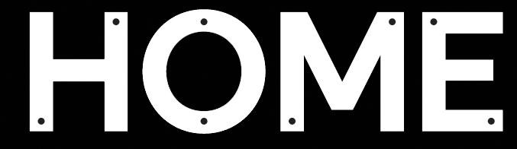

Castlefield Gallery Funders and supporters:

